Façade Design Pattern:-

Gang of Four Definition:-

“Provide a unified interface to a set of interfaces in a subsystem. Façade defines a high-level interface that makes the subsystem easier to use.”

It falls under the category of Structural Design Pattern

Evolved from French word façade, which means “frontage” or “face”

Implementation Guidelines:

* We want to provide a simple interface to a complex subsystem. Subsystems often get more complex as they evolve.
* There are many dependencies between clients and the implementation classes of an abstraction.(In this scenario we introduce a façade to decouple the subsystem from clients and other subsystems thereby promoting subsystem independence and portability)
* We want to layer the subsystems. Use a façade to define an entry point to each subsystem level

Representation Diagram:

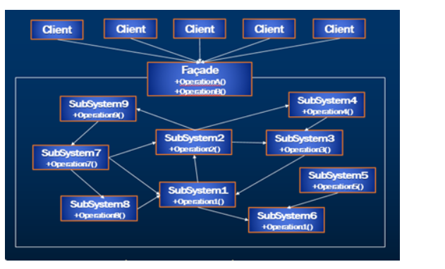

Façade

* Knows which subsystem classes are responsible for a request.
* And it delegates client requests to appropriate subsystem objects

Subsystem classes

* Implement their subsystem functionality to handle work assigned by the Façade objects
* These subsystems have no knowledge of the Façade; that is, they keep no references to it.